2015 AIC Full Time Employment

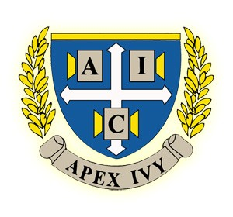
Job Description: Education Consultant

AIC is a growing education company focused on changing China's schools regionally and nationally. We operate out of nine cities across China, primarily mentoring students one on one to develop their character, improve their writing abilities and help them understand universities in the United States. In addition to college consulting for some of China's best students, we also pursue philanthropy, giving over 3 Million RMB in scholarships. We're looking for passionate teachers first and foremost, but also individuals excited about business development and research into the Chinese education system. With a diverse portfolio of projects and connections, AIC is an exciting opportunity for aspiring education enthusiasts.

College Consulting
- This will be a new hire's primary responsibility. Aside from teaching small classes, the main emphasis will be during the application season each year (August to January), when you will mentor students on a one-on-one basis to brainstorm essay topics, plan application strategy and ready them for their undergraduate lives abroad.
Teaching
- Planning and teaching small, discussion based seminars. Teachers have the option of designing their own courses as well as improving our current curriculum materials.
Marketing
- Understanding product offerings
- Marketing to potential students and parents in large seminars, small group and one-to-one settings Project Development
- Variety of ongoing projects, including publications, research, scholarships and community service
- Opportunities to spearhead your own project
Business Development
- New hires are trained under a highly entrepreneurial environment and will be responsible for assisting with the management, marketing, and public relations events for their designated city.
- As a small company, you will receive opportunities to advance your career in where your interests lie. From seeking investment deals to improving operation efficiency, every moment presents an opportunity to learn.

Job Details
Full Time Position Available |  | Education Consultant
Start Date |  | Class of 2015 starts in the Summer of 2015; Earlier Placement Possible
Skills Needed |    | Bachelor’s Degree from US College/University  Fluency in English (required)
 |  | Fluency in Mandarin
 |  | Passion for education is a must
 |  | Teaching experience (recommended)
 |  | Superior writing, critical analysis and communication skills
Application Procedure |  | Please include your resume, cover letter addressing your fit for the education industry, sdfsdfsfsf
 |  | Industry and your interest in working in China, as well as a writing sample (creative
 |  | or research papers are both applicable)
 |  | Send all application materials to: andy.blake@aic-edu.com
 |  | Title your email “YOUR NAME, AIC 2015 Full Time Application”
 |  | For more information, please visit: www.jq-edu.com,
 |  | www.facebook.com/ARelations
Primary Locations |   | Beijing, Chengdu, Hangzhou, Nanjing, Shenzhen, Wuhan, Xi’an, Zhengzhou

